**WEBSITE**

Learning to use good speech sounds takes time and usually follows a pattern. See the speech sound ladder below and remember to practice at your child’s level. If they are currently working on a sound at the word level they won’t be able to produce that sound in sentences yet.

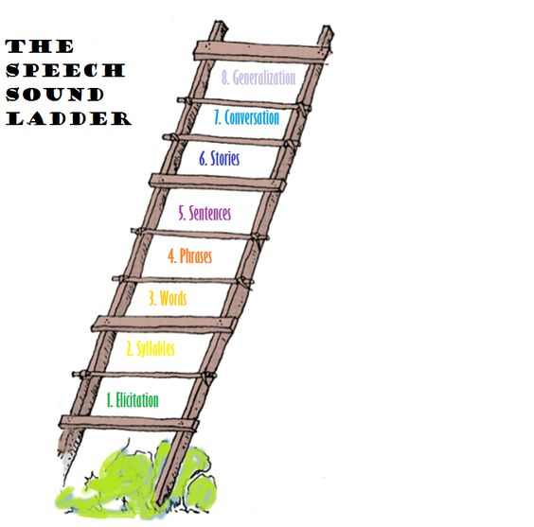

Here’s some information about how to do speech sound practice at home.

<https://www.home-speech-home.com/twenty-5-minute-speech-therapy-activities-you-can-do-at-home.html>

Model

**Speech News**

**March 20, 2020**

Speech Language Pathologist – Kimberlee Churchill

Lord Selkirk School Division

Email: kchurchill@lssd.ca

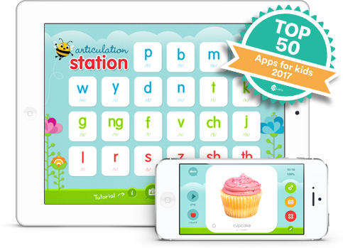

This is a possible resource for speech sound practice. You do not need to purchase the entire app – you can purchase one sound at a time. If your child can produce a sound correctly you can go ahead and practice. If your child continues to have difficulty producing a sound please don’t practice the sound wrong.

At home, the best strategy you can use to help your child improve their speech sounds is to be a good speech model. You are the BEST model for your child’s speech. Do your best to face your child while speaking and speak clearly, emphasizing difficult sounds. If your child doesn’t say a word right, don’t criticize their speech. Simply stress the word again pronouncing it correctly. Always repeat what is said, stressing the speech sound.

**The Rule**

**Repeat** what your child says but say it correctly. Your child does not have to say the correct form after you. What is important is that your child **hears** the correct form.

**Example**

Child: “I need a poon please.”

Adult: “Oh, you need a **sp**oon. Sure, I’ll get you a **sp**oon.”

**Contact Information:**